CHAPTER - 1

INTRODUCTION

1.1 INTRODUCTION**:**

If you’ve traveled anywhere in America by car, bus, or foot, you’ve undoubtedly seen an electronic billboard. To be clear, when we refer to an electronic or digital billboard, we are not only referring to traditional billboards like the ones you see next to freeways, but also smaller digital screens that might appear next to bus benches, shopping centers, or other high traffic areas.

Once hailed as the next big thing in outdoor advertising, digital billboards quickly grew stale. Why? Because even though digital billboards allow a rotation of ads to be displayed, these types of billboards are still very easy to ignore

In order for any advertisement to really capture the attention of a human being, the ad needs to speak to the viewer, both literally and figuratively. This is where smart billboards come into play.

* The use of smart boards has widely increased these days. The applications that can be developed using these smart boards have been increasing day-by-day.
* Smart billboards can also target motorists on the highway or pedestrians passing bus shelters. Companies can attract the customers by doing advertisements.
* These smart bill boards will help them in attracting their customers and make their task easier.
* In this we can upload the required data on the bill board simply by giving inputs through user interface. And we can check the lamps working status which is connected to bill board through the UI.
* Through device we can select the mode of the display and according to the selected mode we can change the data on the display.
* The data can be entered through user interface which is created in node red. We can get the status of the lamps which are connected to the bill boards in the user interface. If any lamp fails we can send notifications to authorities.

CHAPTER – 2

WORKING PRINCIPLE

2.1 Working principle:

* The system is low cost wireless android and website based smart bill board system which is developed to send the desired information instantly to the intended user by using wi-fi transceiver module interfaced with a low cost Node MCU microcontroller board.
* The communication mode between android phone and OLED display in this mediater is Node MCU. interface purpose using ibm Watson cloud.

CHAPTER – 3

BLOCK DIAGRAM

OLED DISPLAY

3.1 Block diagram:

OUTPUT

OLED DISPLAY

PROCESSING UNIT

INPUT

NODE MCU

IBM CLOUD

SMART PHONE

OLED DISPLAY

Block diagram 1: smart bill board using ibm watson

CHAPTER – 4

HARDWARE COMPONENTS

4.1 HARDWARE COMPONENTS**:**

* Node MCU
* Buttons
* LED’s
* OLED Display

4.2 NODE MCU:

The ESP8266 is a low-cost wi-fi chip with full TCP/IP stack and MCU (microcontroller unit) capability produced by shanghai based Chinese manufacturer, Espressif systems. The ESP8285 is an ESP8266with 1 Mib of built-in flash, allowing for single-chip devices capable of connecting to wifi.ESP8266 (presently ESP8266EX) is a chip with which Manufacturers are making wirelessly networkable modules. More specifically, ESP8266 is a system-on-chip (soc) with capabilities for 2.4 Ghz w0i-fi (802.11 b/g/n, supporting WPA/WPA2), general-purpose input/output (16 GPIO), inter-integrated circuit (I²C), analog -to-digital conversion (10-bit ADC), serial peripheral interface (SPI), I²S interfaces with DMA (sharing pins with GPIO), UART (on dedicated Pins, plus a transmit-only UART can be enabled on GPIO2), and pulse-width modulation (PWM). The processor core, called "L106" by Espressif, is based on Tensilica's diamond  
Standard 106micro 32-bit processor controller core and runs at 80 Mhz (or overclocked to 160 mhz). It has a 64 KB boot ROM, 64 KB instruction RAM and 96 KB data RAM.   
External flash memory can be accessed through SPI.Further as a prototype of ESP8266 and advancement to ESP8266 is added with node MCU ESP8266.

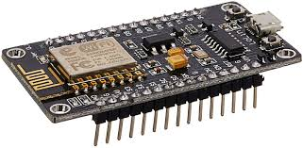

Fig 1 : Node MCU

4.3 OLED:

The OLED display doesn’t require backlight, which results in a very nice contrast in dark environments. Additionally, its pixels consume energy only when they are on, so the OLED display consumes less power when compared with other displays.  
The model we’re using here has only four pins and communicates with the arduino using I2C communication protocol. There are models that come with an extra RESET pin. There are also other OLED displays that communicate using SPI communication.

4.3.1 Pin wiring:

Because the OLED display uses I2C communication protocol, wiring is very simple.

You just need to connect to the Arduino Uno I2C pins as shown in the table below.

|  |  |
| --- | --- |
| **Pin** | **Wiring to Node MCU** |
| Vin | 5V |
| GND | GND |
| SCL | D1 |
| SDA | D2 |

Table 1 : pin wiring

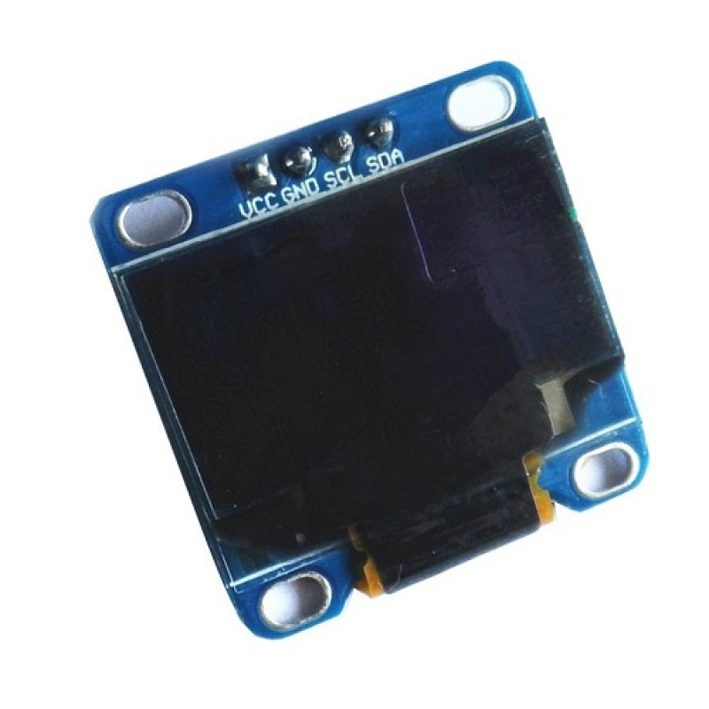

Fig 2 : OLED

4.4 BASIC SHIELD:

This basic shield can be interface with 5v or 3.3v logic microcontroller boards like arduino,avr,pic,8051,arm etc..  
Basic shield is very popular shield for interfacing of electronics component with microcontroller like led‘s , variable resister , push button , ldr etc.  
all components are arranged in a proper manner so that we can use it with your microcontroller to learn basic programming of microcontroller in your projects.  
This shield helps you how to deal with basic electronics components in your   
projects

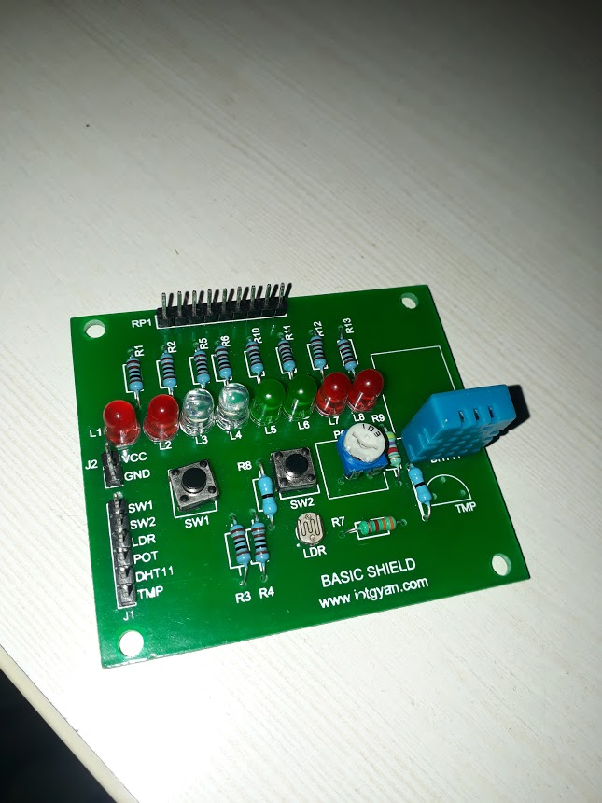

Fig 3 : Basic shield

CHAPTER – 5

SOFTWARE REQUIRED

5.1 SOFTWARES REQUIRED:

* Arduino IDE
* IBM Watson Cloud platform

5.2 ARDUINO IDE:

The Arduino integrated development environment (IDE) is a class-platform application (for windows, macos, Linux) that is written in the programming language java. It is used to write and up load programs to arduino compatible boards, but salso,with the help of 3rd party cores, other vendor development boardsThe source code for the IDE is released under the GNU general public license , version 2.the arduino IDE supports the languages C and C++ using special rules of code structuring.The arduino IDE supplies a software library from the wiring project, which provides many common input and output procedures. User-written code only requires two basic functions, for starting the sketch and the main program loop, that are compiled and Linked with a Program stub *main()* into an executable cyclic executive program with the GNU toolchain, also included with the IDE distribution.the arduino IDE employs the program *avrdude* to convert the executable code into a text file in hexadecimal encoding that is loaded into the arduino board by a loader program in the board's firmware.

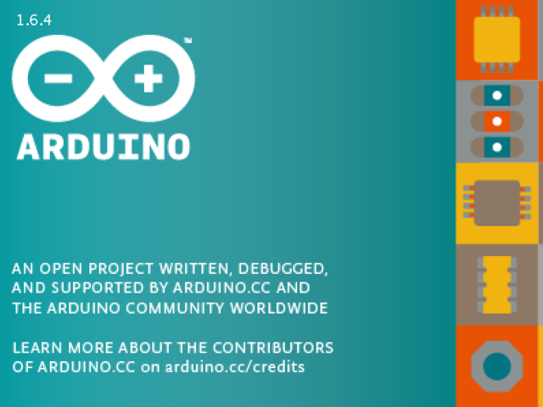

Fig 4 : Arduino IDE

4.5 IBM WATSON CLOUD PLATFORM:

  
Fig 5 : IBM cloud

Ibm cloud is a platform that helps developers build and   
run modern apps and services it provides developers with instant access to the compute and services they need to launch quickly, iterate continuously and scale with success. With services across mobile , iot, ibm Watson and more ibm cloud is an ideal platform to power the next wave of apps that thrive on data.  
 Ibm cloud is a suite of cloud computing services from ibm that offers both platform as a service and infrastructure as a service.  
 Ibm cloud platform supports access to other ibm tools and services including ibm Watson and ibm cloud functions for serverless computing as well as those from third party vendors.

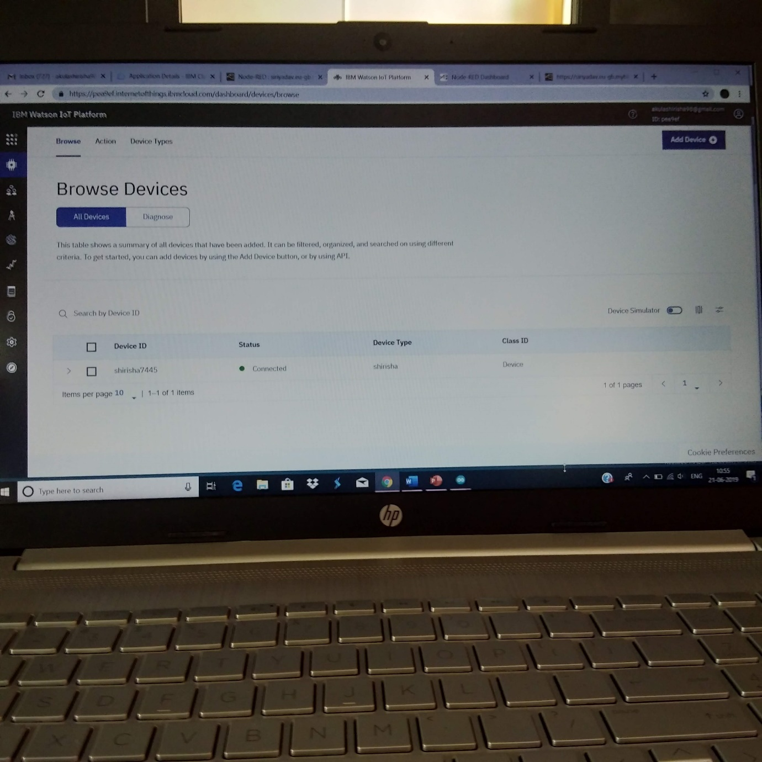

Fig 6 : Device connected to ibm cloud

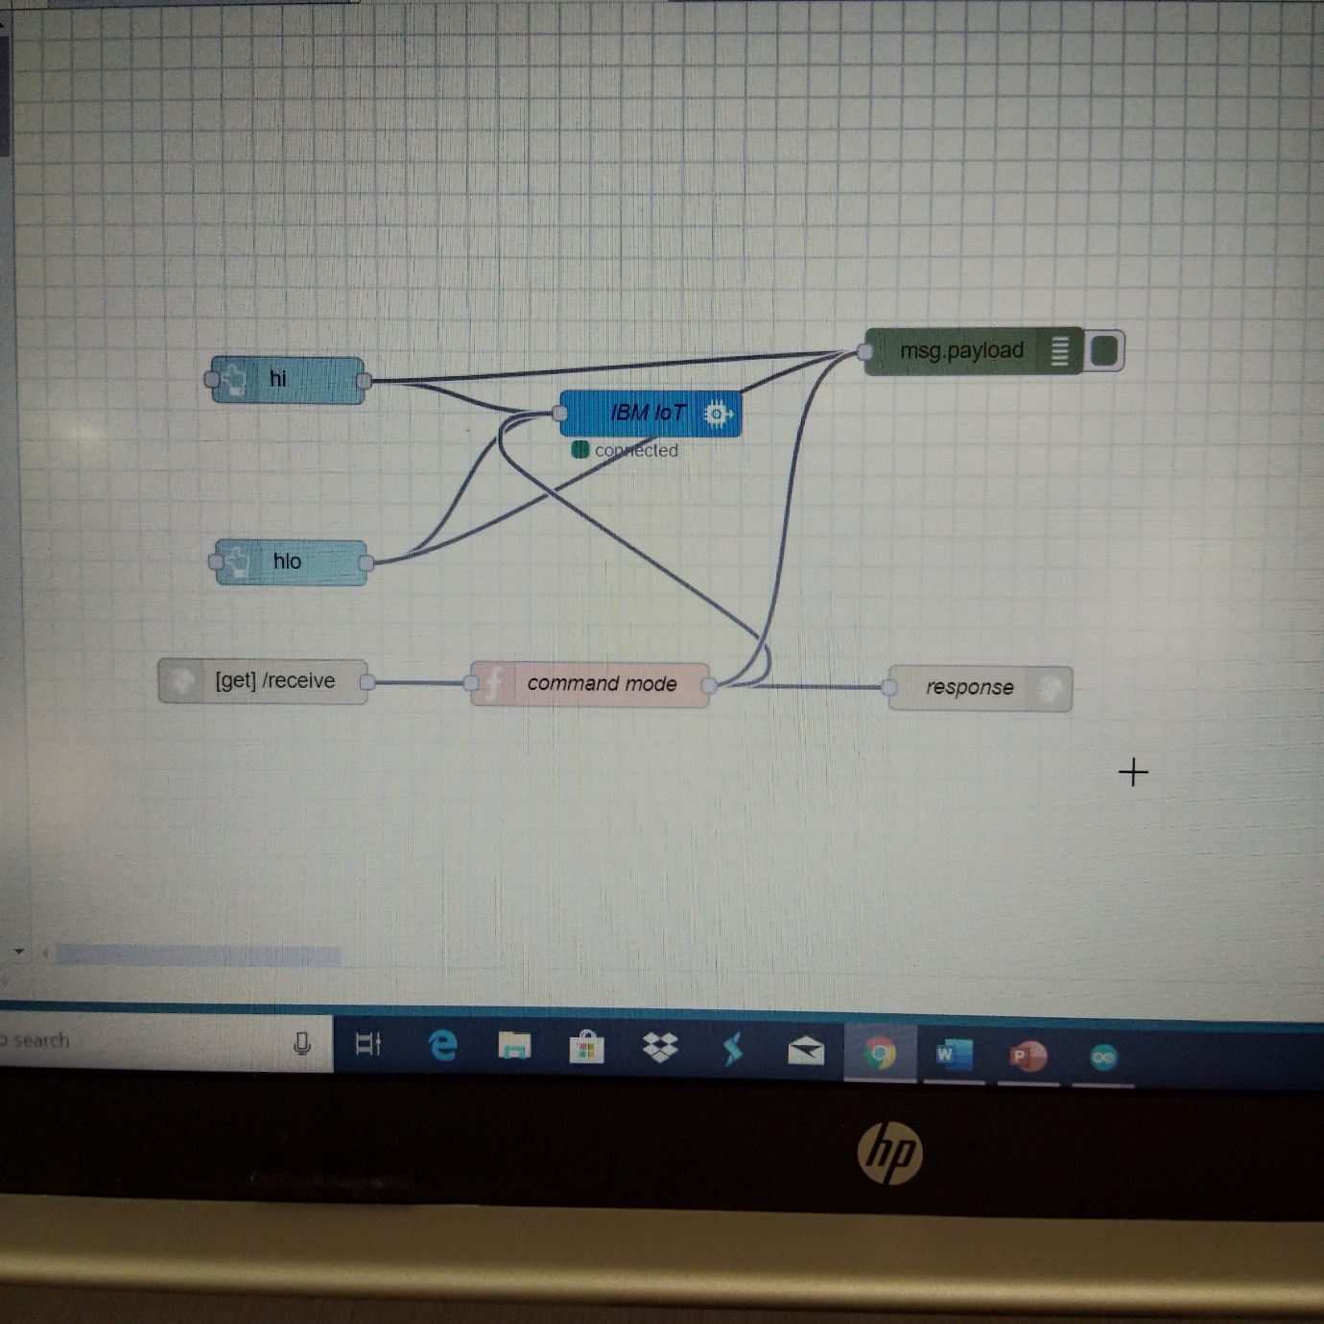

Fig 7 : Connections of Node RED

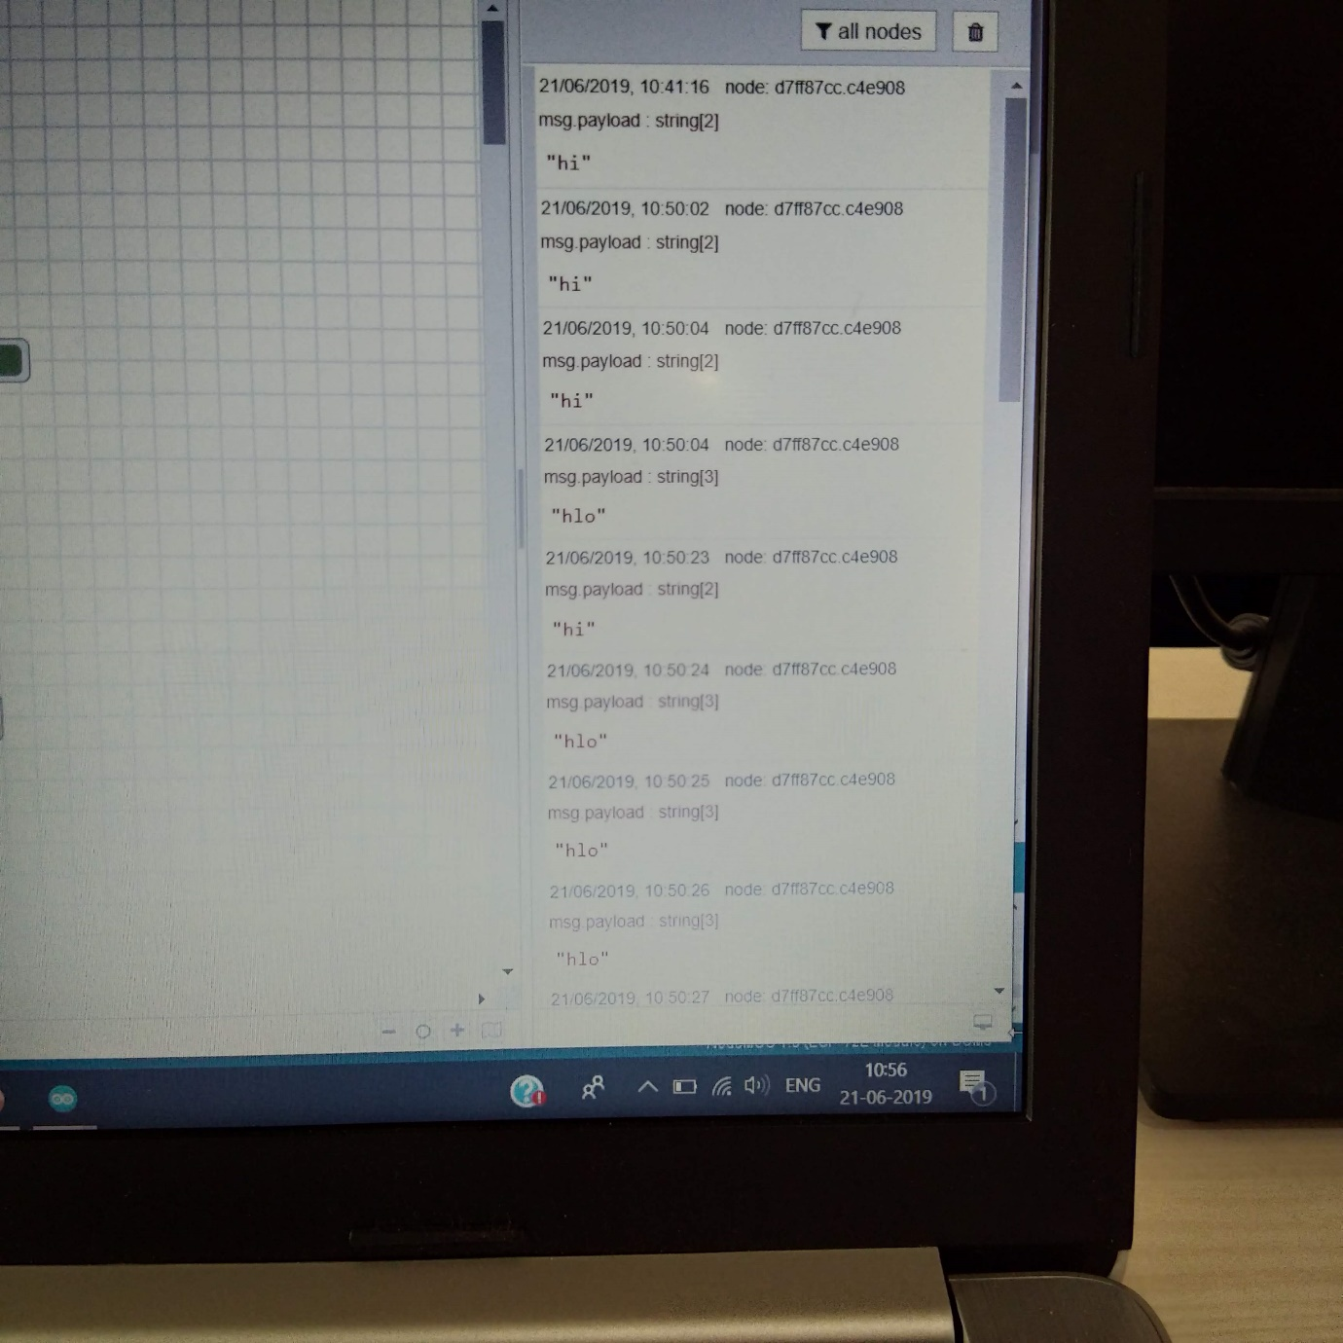

Fig 8 : Output of Node RED

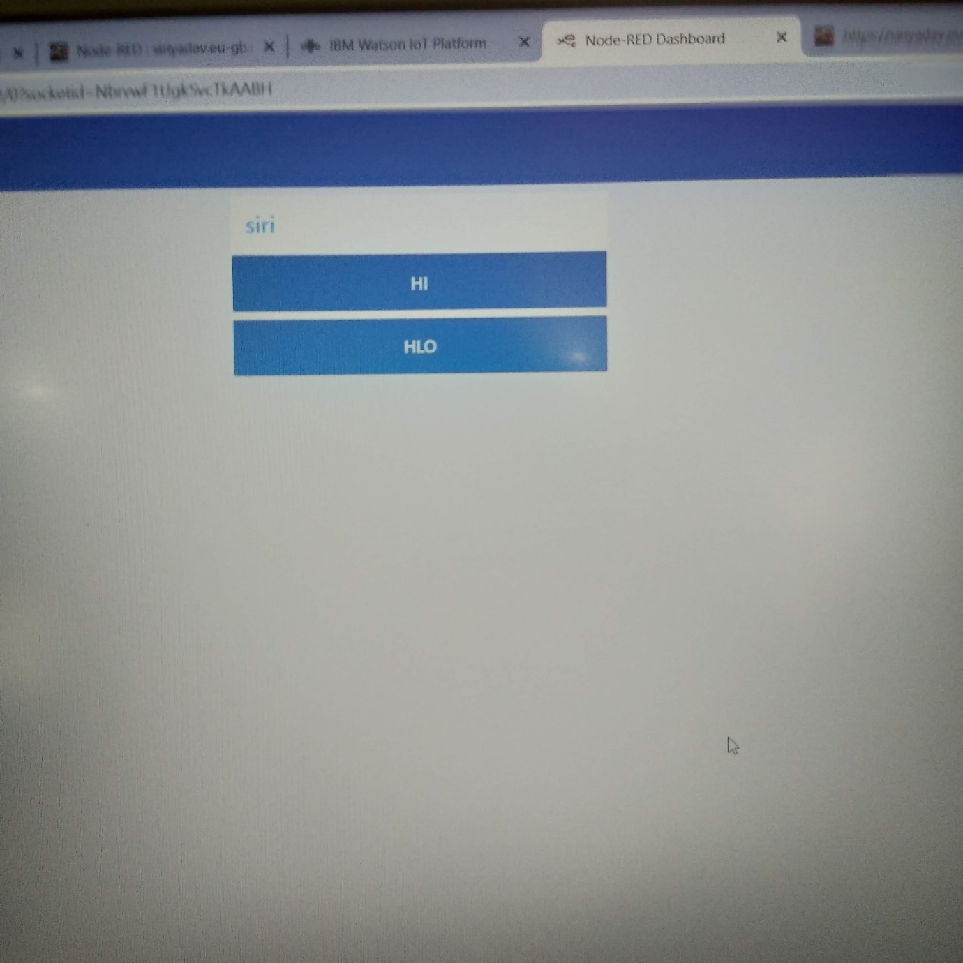

Fig 9 : Node RED Dashboard

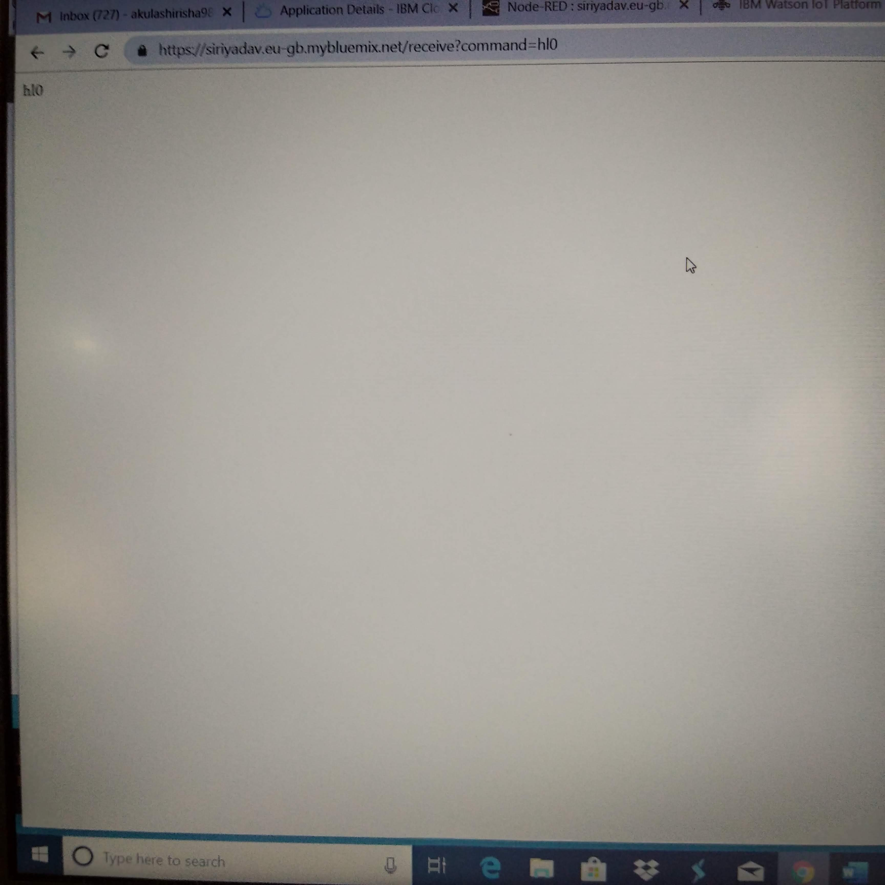

Fig 10 : cross check output of Node RED of hlo

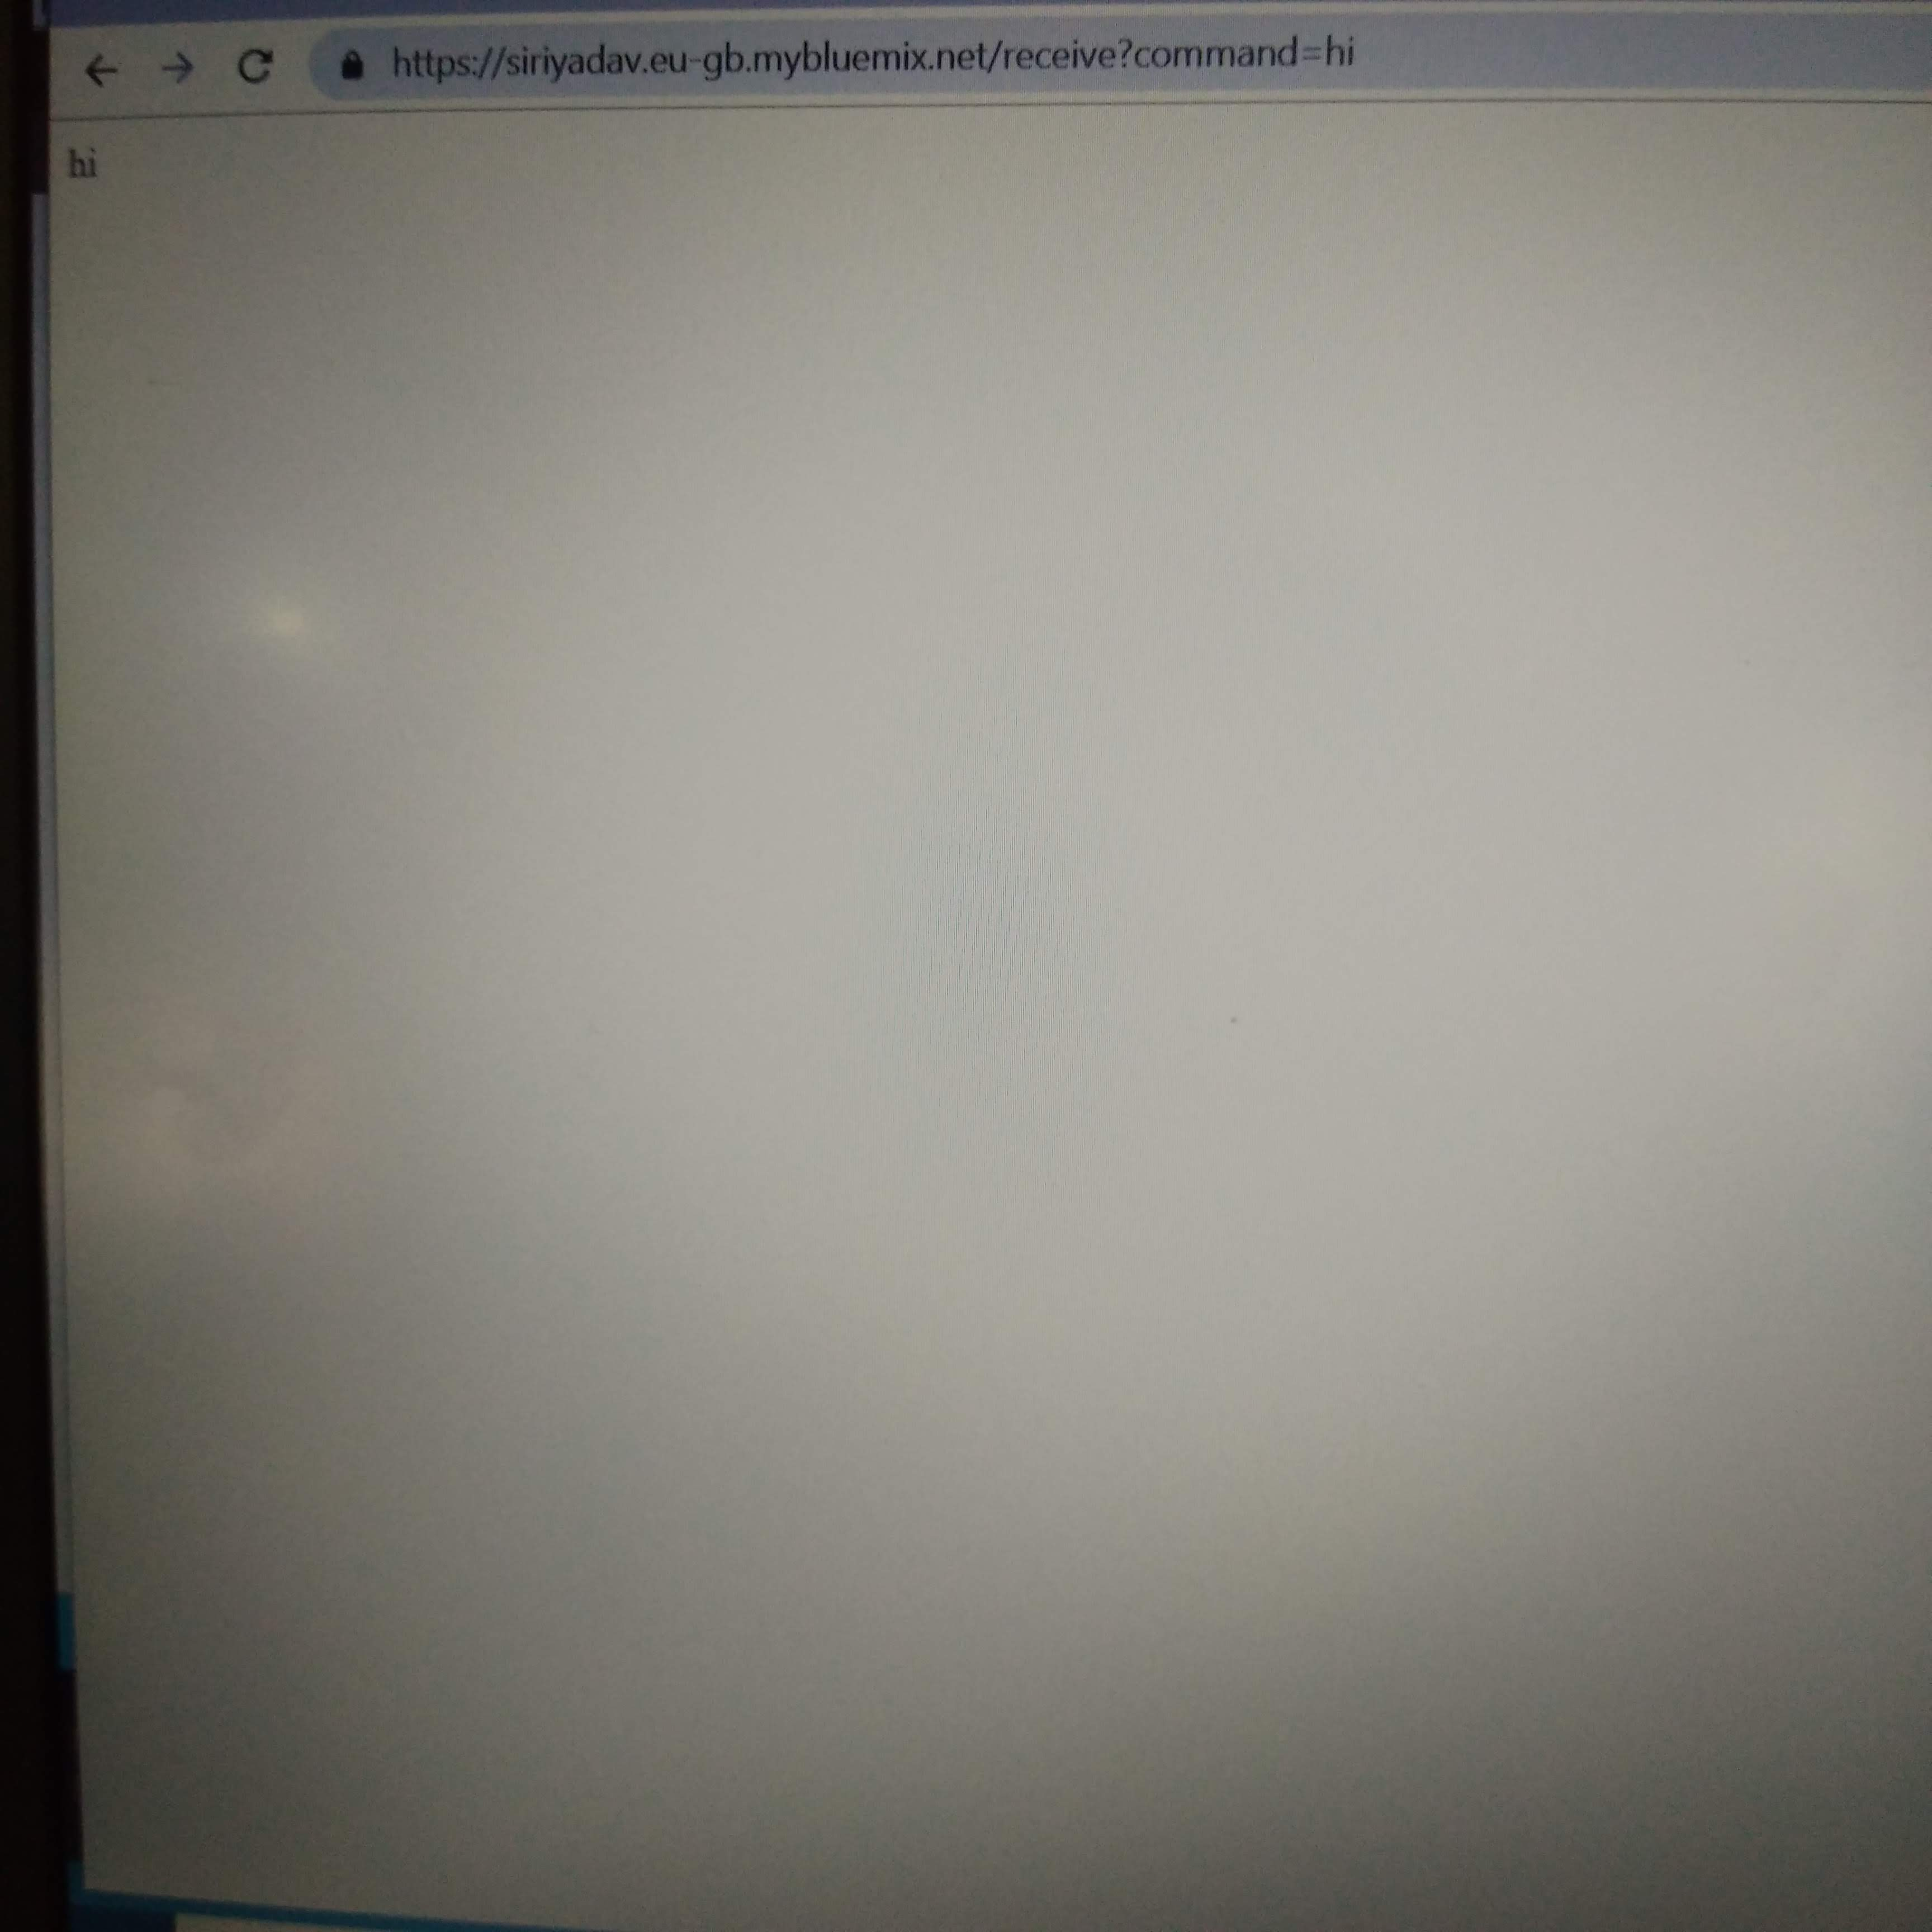

Fig 11 : Cross check output of Node RED of hi

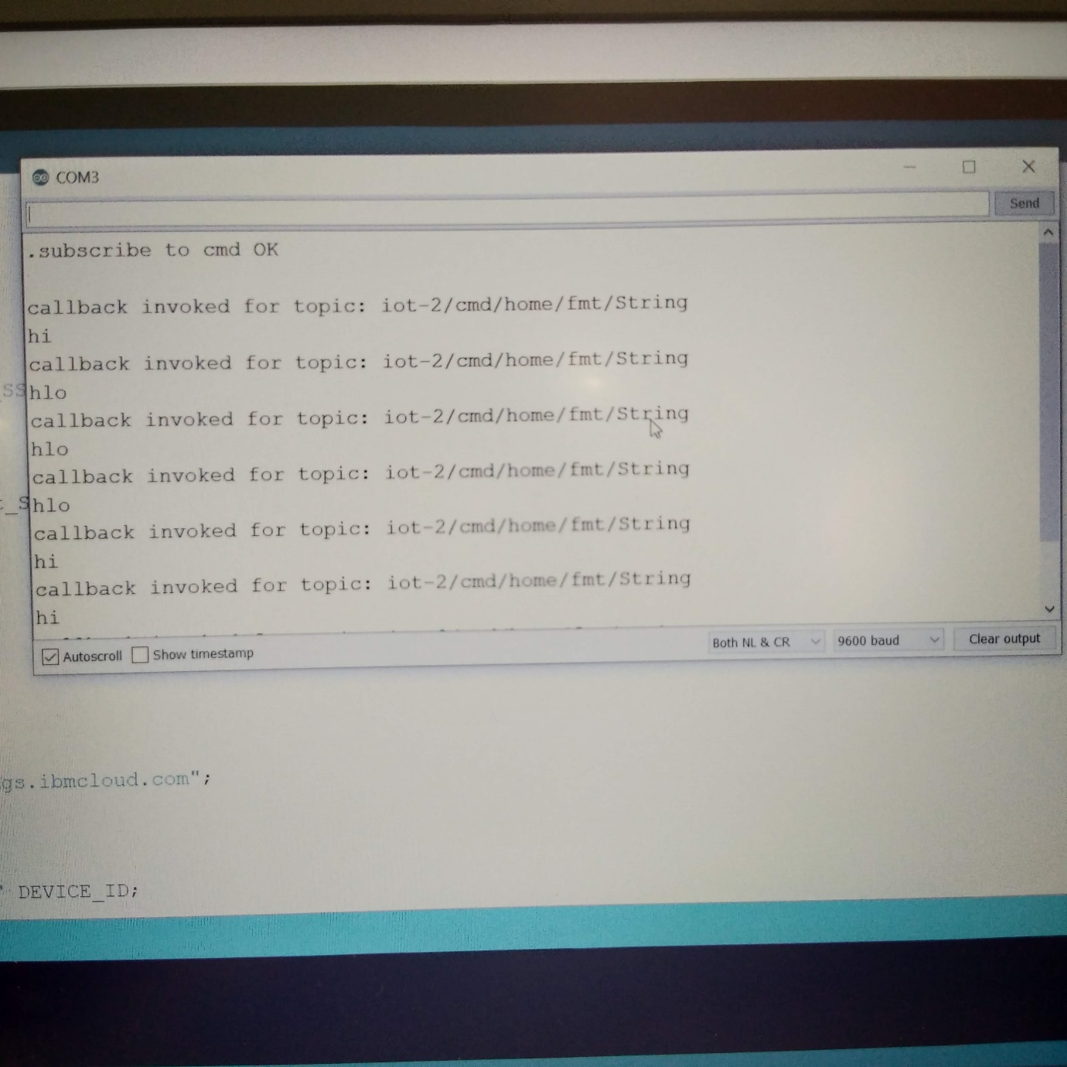

Fig 12 : Output of serial monitor

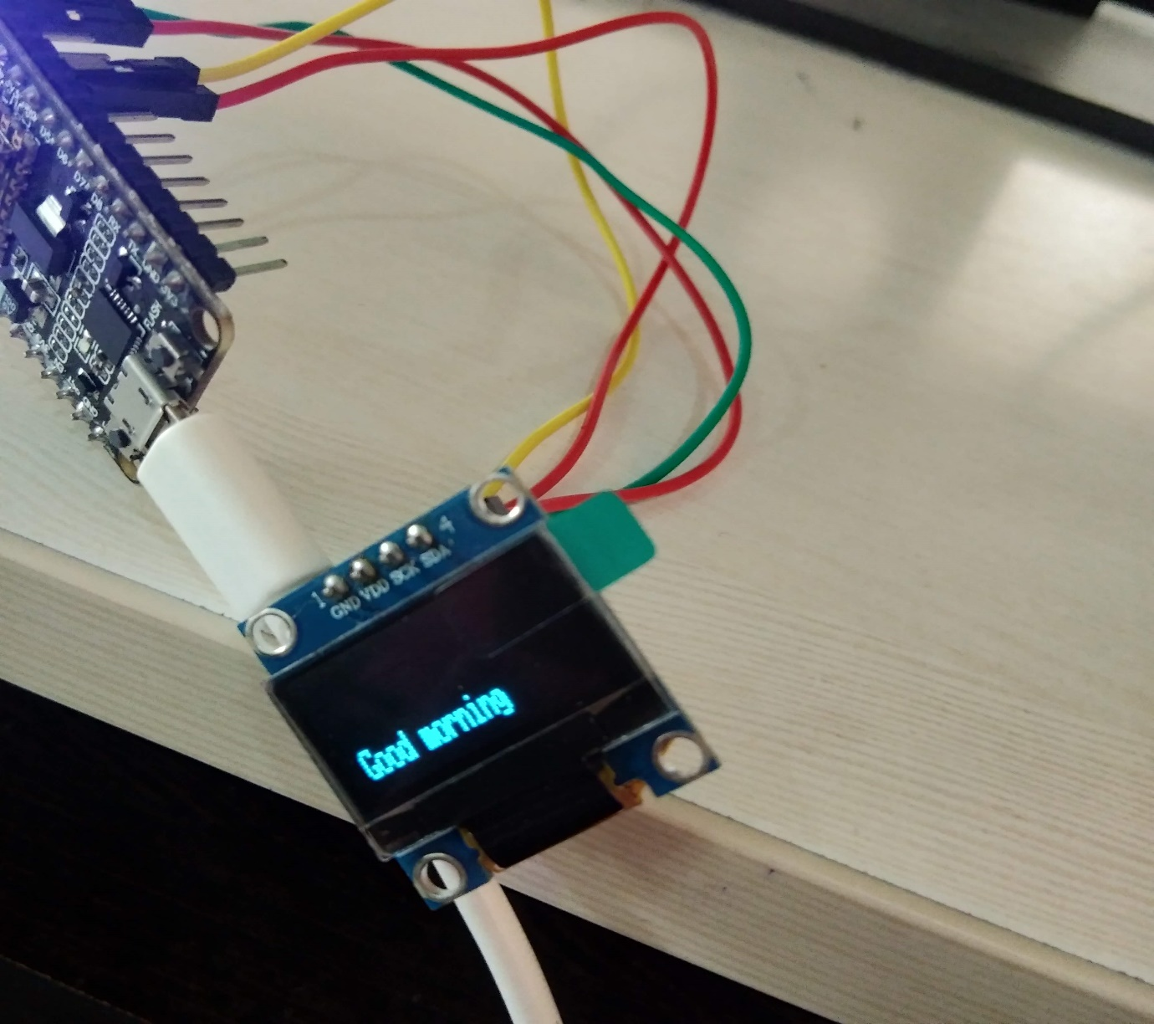

Fig 13 : Pressing no button

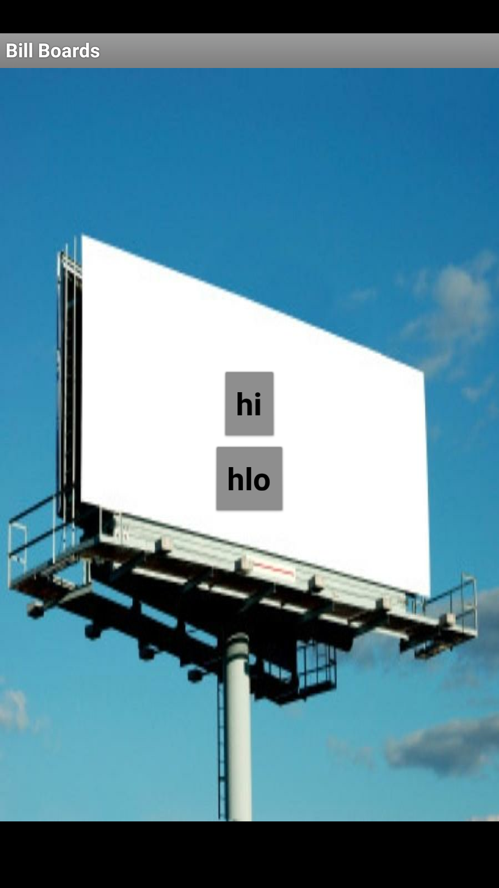

Fig 14 : Smart bill board app

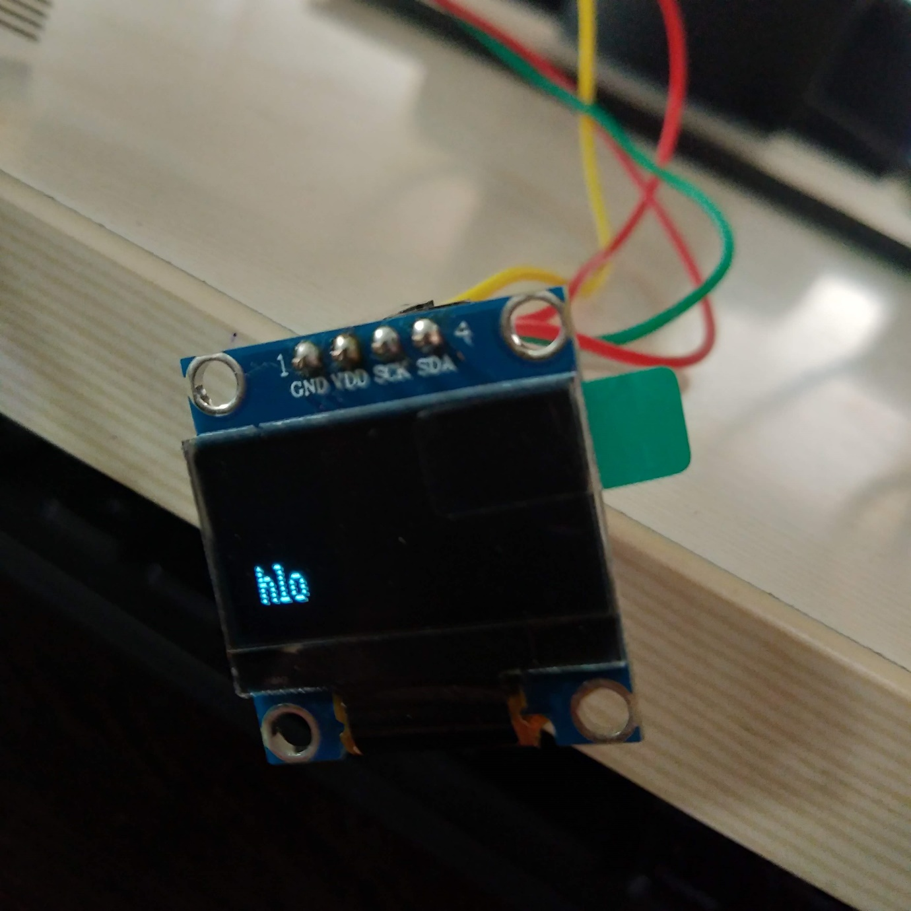 Fig 15 : press hlo

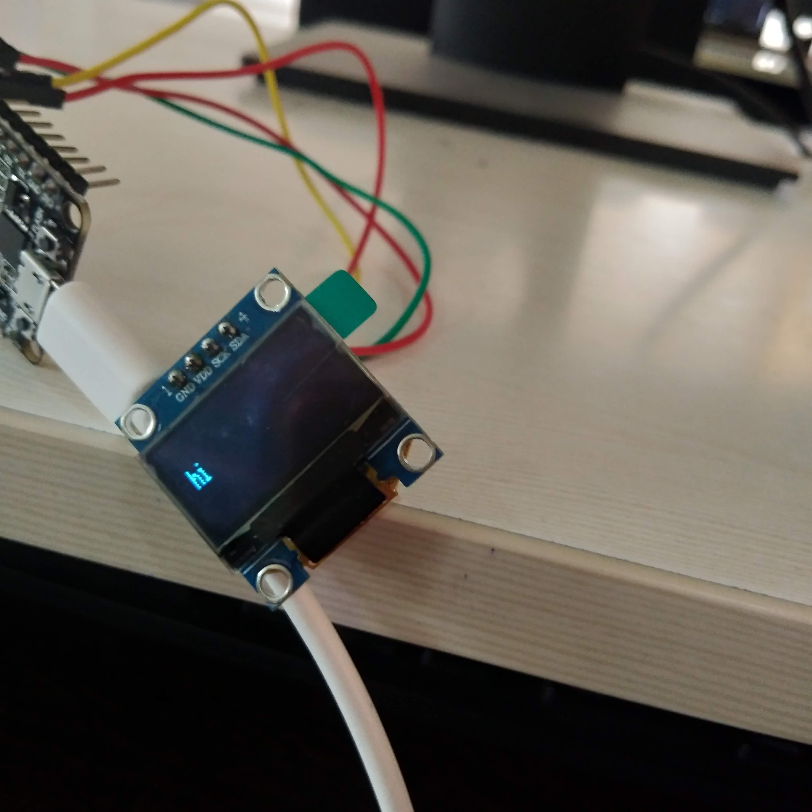

Fig 16 : Press hi

Fig 17 : Arduino programing

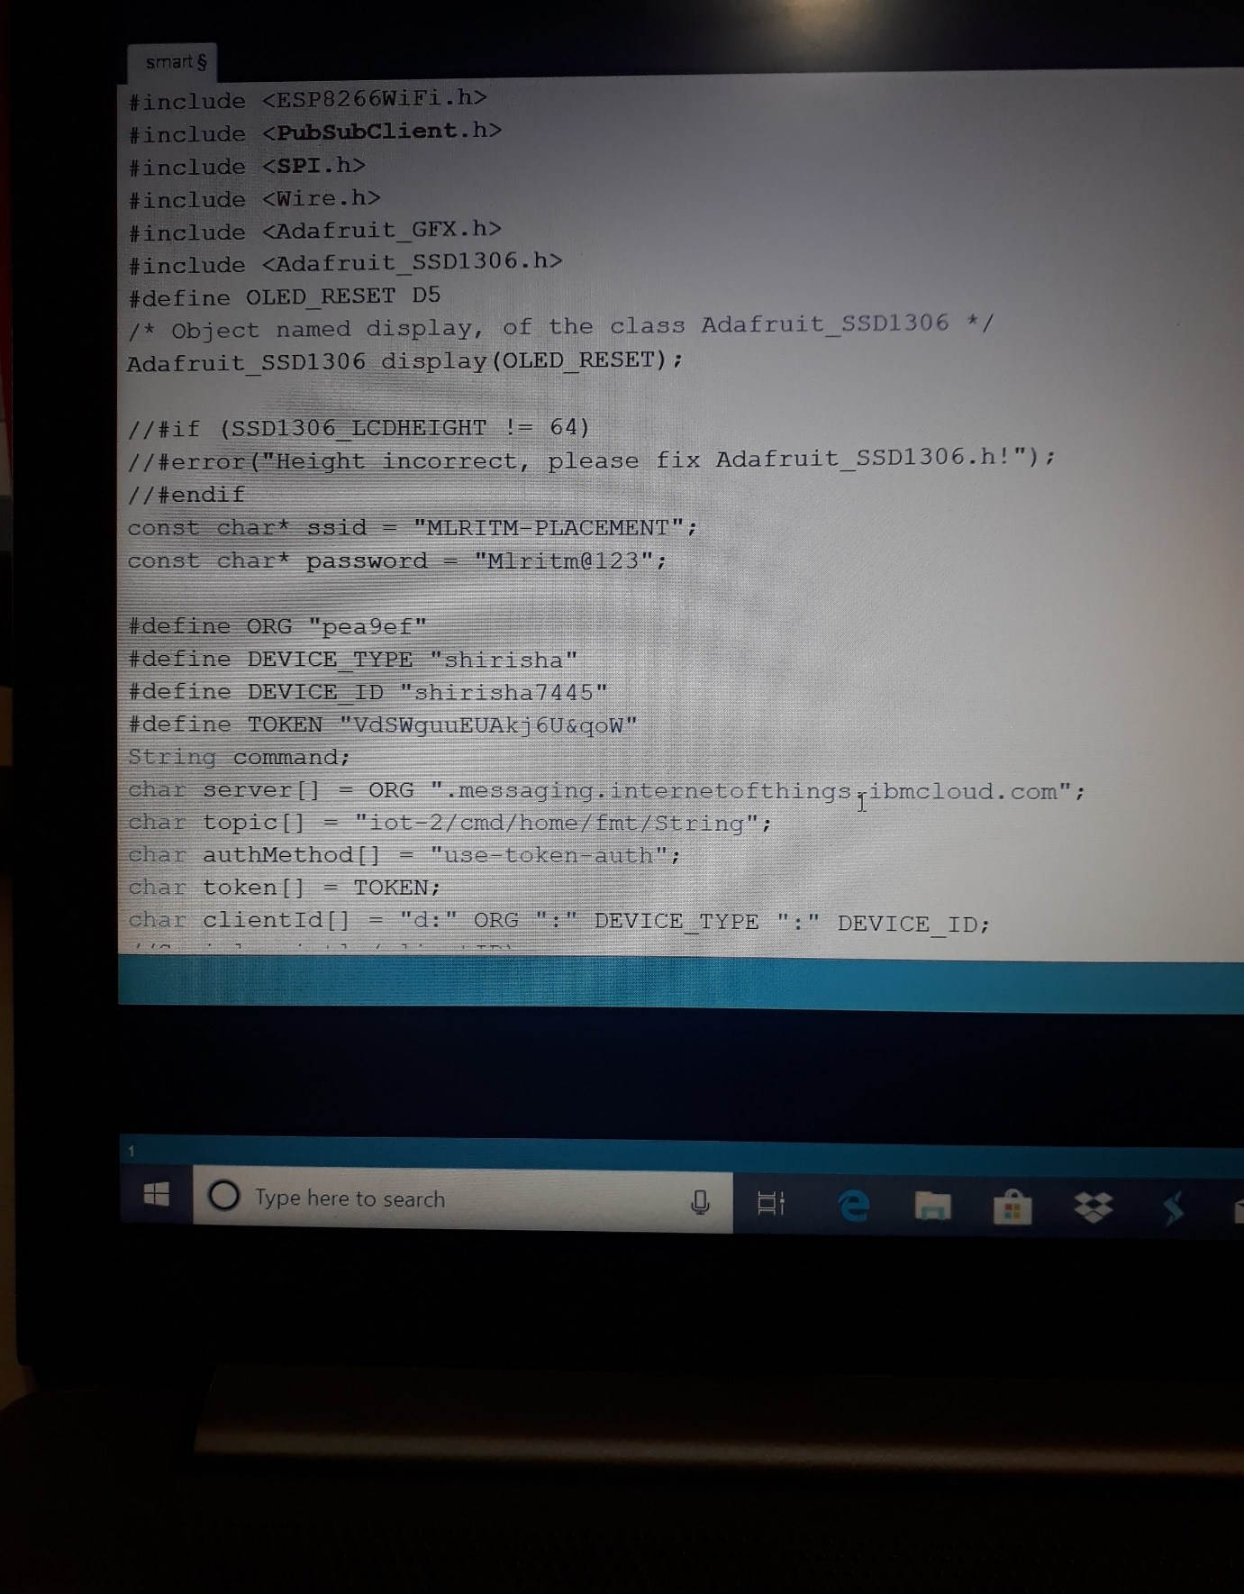

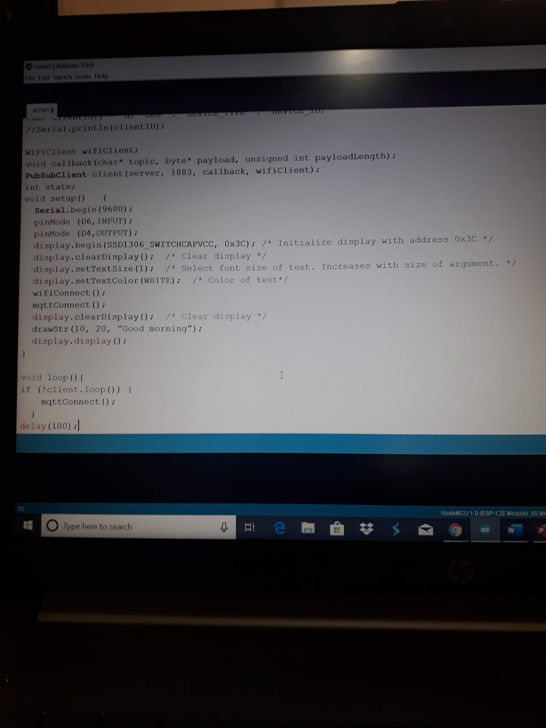

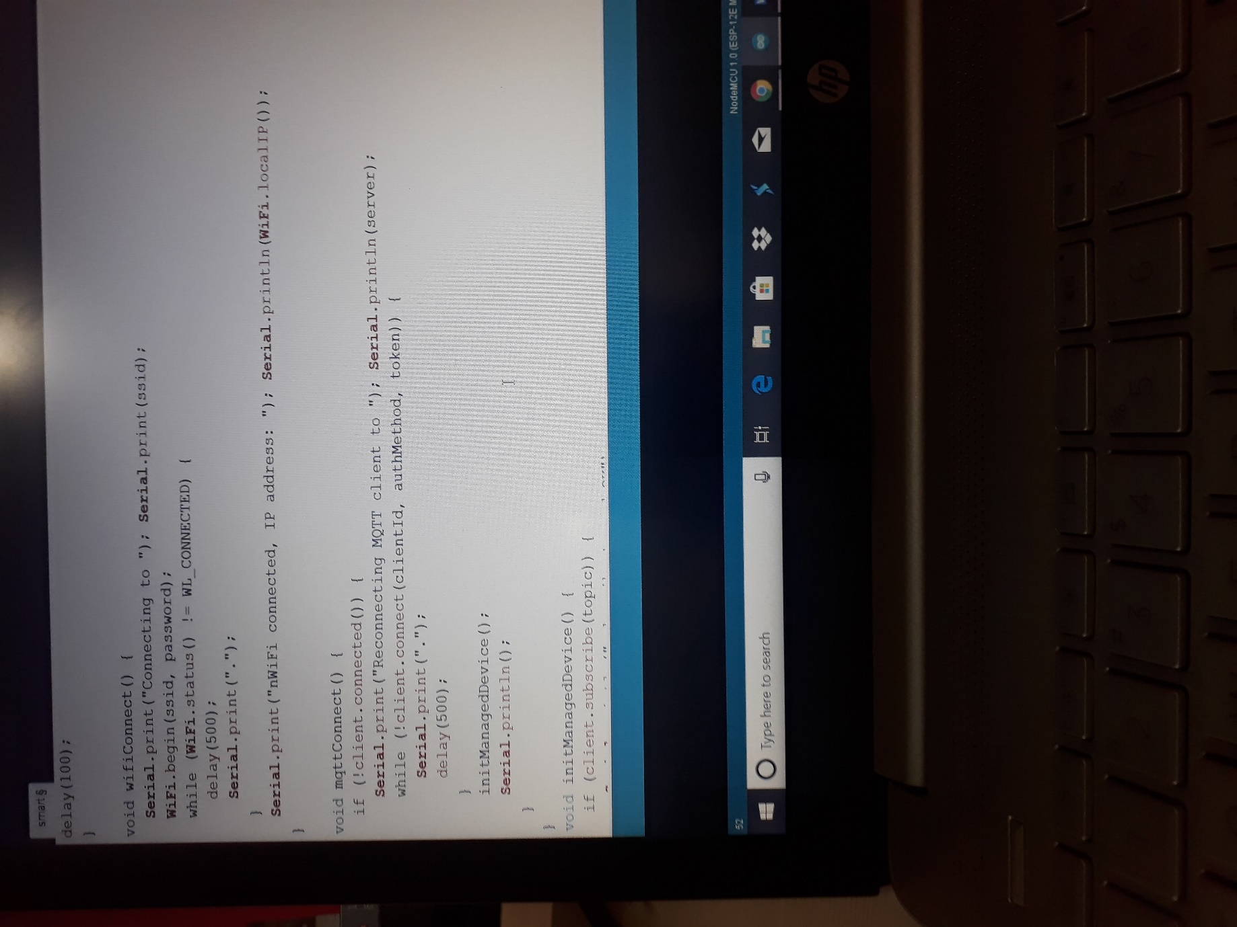

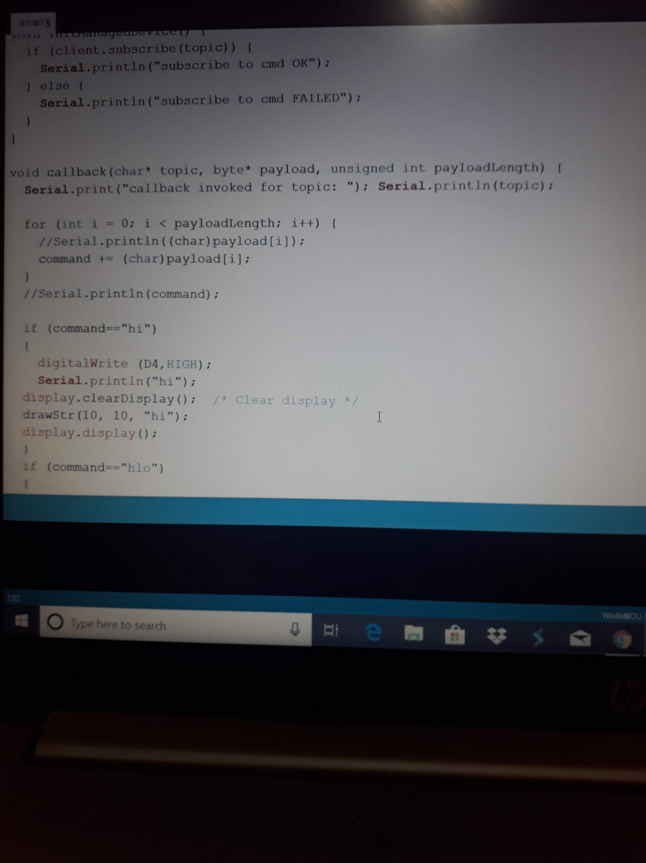

CHAPTER – 6

ADVANTAGES AND DISADVANTAGES

6.1 ADVANTAGES:

* Huge and eye-catching
* Targets a large and diverse marketcc
* Easily registered information
* Increased frequency of consumer exposure
* Effective medium of awareness advertising
* Targets middle and upper classes
* Photographic information (strong visual effect)
* Builds company reputation and product image
* Quick rise in sales
* Guaranteed audience
* Customers find you
  1. DISADVANTAGES:
* Risk from vandalism, weather conditions
* Cost is high
* Visibility issue
* Stationary mode of advertising
* Time insensitive
* No feedback
* No advantage of space
* Does not target a specific market
* Short term advertising tool
* Limited informationss

CHAPTER - 7

CONCLUSION

7.1 CONCLUSION**:**

* The billboard is a medium that may bring nostalgic memories to most people driving on the road today and while the 10-year version of the billboard may not be recognizable to those who know it today, there is huge potential for the quality of deliverability and content in the future. Perceived mostly as an advertising vehicle, there is opportunity for the billboard industry to alter methods of medium engagement that can balance the duties of privacy protection, providing meaningful information to those who care, and keeping the technology as exciting and intriguing as possible to the receiving community.